**INTEGRATION OF TDM & SV**

The following points explain the information flow that is shown in the illustration:

1. Register a file object to the CA TDM Portal.   
   For SV integration, the file object must be of type WSDL, XML RR pair, JSON RR pair, or REST RR pair.
2. Create and register derived objects in the target database based on the registered file object.
3. Import the sample RR pair data into the derived objects.
4. Define data generation rules.  
   This step adds data generation rules to the derived objects, which help during the process of data generation.
5. Publish the data into derived objects.  
   This step adds more data to the derived objects.
6. Export the generated data (as RR pair files) into a virtual service in CA Service Virtualization.

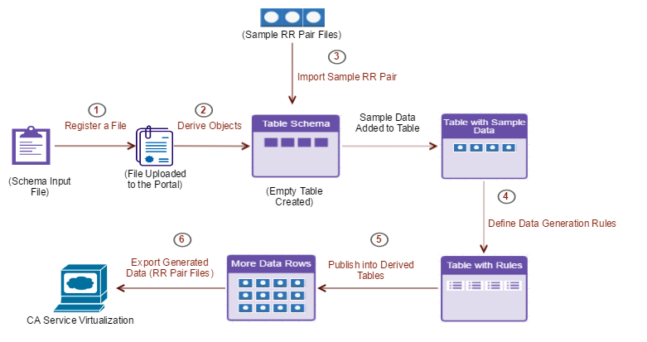

Let us see an example of getting Supplier Information Based on a ZIP Code. Here we test a scenario where we virtualize a service to get details about the supplier based on a ZIP code. In these XML RR pairs, the request XML file must include the ZIP code information and the corresponding response XML file must include the related supplier information. We generate multiple similar XML files, adhering to the same schema defined in the associated WSDL file. All the XML RR pairs are then hosted in the virtual service.

Steps to be followed:

1. Create a Database in SQL Server.
2. [Create a Portal Project](https://docops.ca.com/ca-test-data-manager/4-1/en/provisioning-test-data/data-discovery/data-discovery-using-the-ca-tdm-portal/prepare-test-data-for-non-relational-data-sources/xsd-xml-wsdl-json-rr-pair-file-types/integration-with-ca-service-virtualization#IntegrationwithCAServiceVirtualization-CreateaPortalProject).
3. [Create a Connection Profile](https://docops.ca.com/ca-test-data-manager/4-1/en/provisioning-test-data/data-discovery/data-discovery-using-the-ca-tdm-portal/prepare-test-data-for-non-relational-data-sources/xsd-xml-wsdl-json-rr-pair-file-types/integration-with-ca-service-virtualization#IntegrationwithCAServiceVirtualization-CreateaConnectionProfile).
4. [Register a File Object (WSDL)](https://docops.ca.com/ca-test-data-manager/4-1/en/provisioning-test-data/data-discovery/data-discovery-using-the-ca-tdm-portal/prepare-test-data-for-non-relational-data-sources/xsd-xml-wsdl-json-rr-pair-file-types/integration-with-ca-service-virtualization#IntegrationwithCAServiceVirtualization-RegisteraFileObject(WSDL)).
5. [Create and Register Derived Objects](https://docops.ca.com/ca-test-data-manager/4-1/en/provisioning-test-data/data-discovery/data-discovery-using-the-ca-tdm-portal/prepare-test-data-for-non-relational-data-sources/xsd-xml-wsdl-json-rr-pair-file-types/integration-with-ca-service-virtualization#IntegrationwithCAServiceVirtualization-CreateandRegisterDerivedObjects).
6. [Create a Data Generator](https://docops.ca.com/ca-test-data-manager/4-1/en/provisioning-test-data/data-discovery/data-discovery-using-the-ca-tdm-portal/prepare-test-data-for-non-relational-data-sources/xsd-xml-wsdl-json-rr-pair-file-types/integration-with-ca-service-virtualization#IntegrationwithCAServiceVirtualization-CreateaDataGenerator).
7. [Import the Sample RR Pairs into Derived Objects](https://docops.ca.com/ca-test-data-manager/4-1/en/provisioning-test-data/data-discovery/data-discovery-using-the-ca-tdm-portal/prepare-test-data-for-non-relational-data-sources/xsd-xml-wsdl-json-rr-pair-file-types/integration-with-ca-service-virtualization#IntegrationwithCAServiceVirtualization-ImporttheSampleRRPairsintoDerivedObjects).
8. [Verify Records in the Database After Import](https://docops.ca.com/ca-test-data-manager/4-1/en/provisioning-test-data/data-discovery/data-discovery-using-the-ca-tdm-portal/prepare-test-data-for-non-relational-data-sources/xsd-xml-wsdl-json-rr-pair-file-types/integration-with-ca-service-virtualization#IntegrationwithCAServiceVirtualization-VerifyRecordsintheDatabaseAfterImport).
9. [Add Data Generation Rules](https://docops.ca.com/ca-test-data-manager/4-1/en/provisioning-test-data/data-discovery/data-discovery-using-the-ca-tdm-portal/prepare-test-data-for-non-relational-data-sources/xsd-xml-wsdl-json-rr-pair-file-types/integration-with-ca-service-virtualization#IntegrationwithCAServiceVirtualization-AddDataGenerationRules).
10. [Publish More Data into Derived Objects](https://docops.ca.com/ca-test-data-manager/4-1/en/provisioning-test-data/data-discovery/data-discovery-using-the-ca-tdm-portal/prepare-test-data-for-non-relational-data-sources/xsd-xml-wsdl-json-rr-pair-file-types/integration-with-ca-service-virtualization#IntegrationwithCAServiceVirtualization-PublishMoreDataintoDerivedObjects).
11. [Verify Extra Records in the Database After Publishing](https://docops.ca.com/ca-test-data-manager/4-1/en/provisioning-test-data/data-discovery/data-discovery-using-the-ca-tdm-portal/prepare-test-data-for-non-relational-data-sources/xsd-xml-wsdl-json-rr-pair-file-types/integration-with-ca-service-virtualization#IntegrationwithCAServiceVirtualization-VerifyExtraRecordsintheDatabaseAfterPublishing).
12. [Create a Virtual Service in CA Service Virtualization](https://docops.ca.com/ca-test-data-manager/4-1/en/provisioning-test-data/data-discovery/data-discovery-using-the-ca-tdm-portal/prepare-test-data-for-non-relational-data-sources/xsd-xml-wsdl-json-rr-pair-file-types/integration-with-ca-service-virtualization#IntegrationwithCAServiceVirtualization-CreateaVirtualServiceinCAServiceVirtualization).
13. [Configure the Virtual Service Connection in the CA TDM Portal](https://docops.ca.com/ca-test-data-manager/4-1/en/provisioning-test-data/data-discovery/data-discovery-using-the-ca-tdm-portal/prepare-test-data-for-non-relational-data-sources/xsd-xml-wsdl-json-rr-pair-file-types/integration-with-ca-service-virtualization#IntegrationwithCAServiceVirtualization-ConfiguretheVirtualServiceConnectioninthePortal).
14. [Export the Generated Data (RR Pairs) into the Virtual Service](https://docops.ca.com/ca-test-data-manager/4-1/en/provisioning-test-data/data-discovery/data-discovery-using-the-ca-tdm-portal/prepare-test-data-for-non-relational-data-sources/xsd-xml-wsdl-json-rr-pair-file-types/integration-with-ca-service-virtualization#IntegrationwithCAServiceVirtualization-ExporttheGeneratedData(RRPairs)intotheVirtualService).
15. [Verify the RR Pairs Added to the Virtual Service](https://docops.ca.com/ca-test-data-manager/4-1/en/provisioning-test-data/data-discovery/data-discovery-using-the-ca-tdm-portal/prepare-test-data-for-non-relational-data-sources/xsd-xml-wsdl-json-rr-pair-file-types/integration-with-ca-service-virtualization#IntegrationwithCAServiceVirtualization-VerifytheRRPairsAddedtotheVirtualService).

**Create a DB in SQL SERVER**

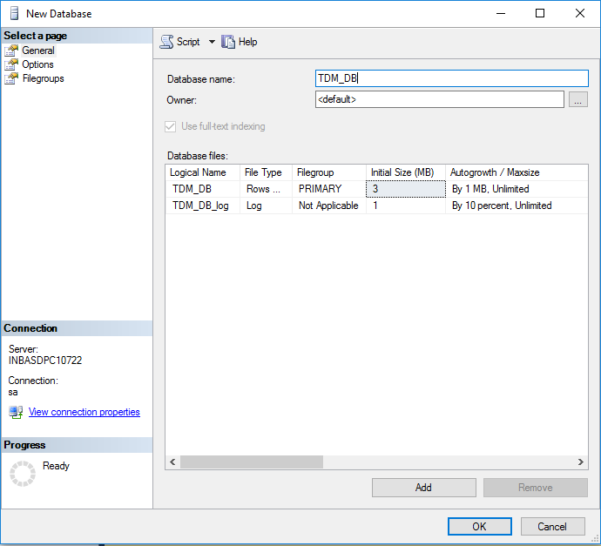

**Create a Portal Project**

1. Access the CA TDM Portal.
2. Select the Project Manager icon (gear icon).
3. Click **New Project**.
4. Enter information in the following fields for this example:
   * **Name**: Name of the CA TDM Portal project.
   * **Description:** Description of the project.
   * **Version:** Project version.
   * **Version Description**: Project version description.
5. Click **Save**.

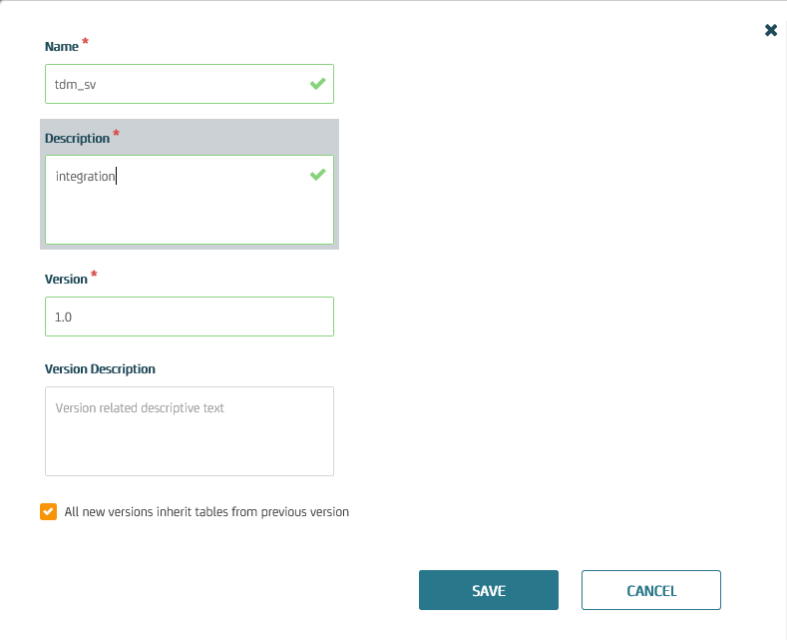

[**Create a Connection Profile**](https://docops.ca.com/ca-test-data-manager/4-1/en/provisioning-test-data/data-discovery/data-discovery-using-the-ca-tdm-portal/prepare-test-data-for-non-relational-data-sources/xsd-xml-wsdl-json-rr-pair-file-types/integration-with-ca-service-virtualization#IntegrationwithCAServiceVirtualization-CreateaConnectionProfile)**.**

1. Access the CA TDM Portal.
2. Click Configuration in the left pane.
3. Click the Connection Profiles option.
4. Click the New Profile button.
5. Enter information in the following fields for this example:
   * Profile Name: Specify the profile name.
   * Description: Specify the connection description.
   * DBMS: SQL SERVER.
   * Server: Specify the server where the Microsoft SQL Server database is available.
   * Database: Name of the Database.
   * Port: 1433
   * User Name: sa.
   * Password: Password123.
6. Click Test to verify the connection. Click Save.

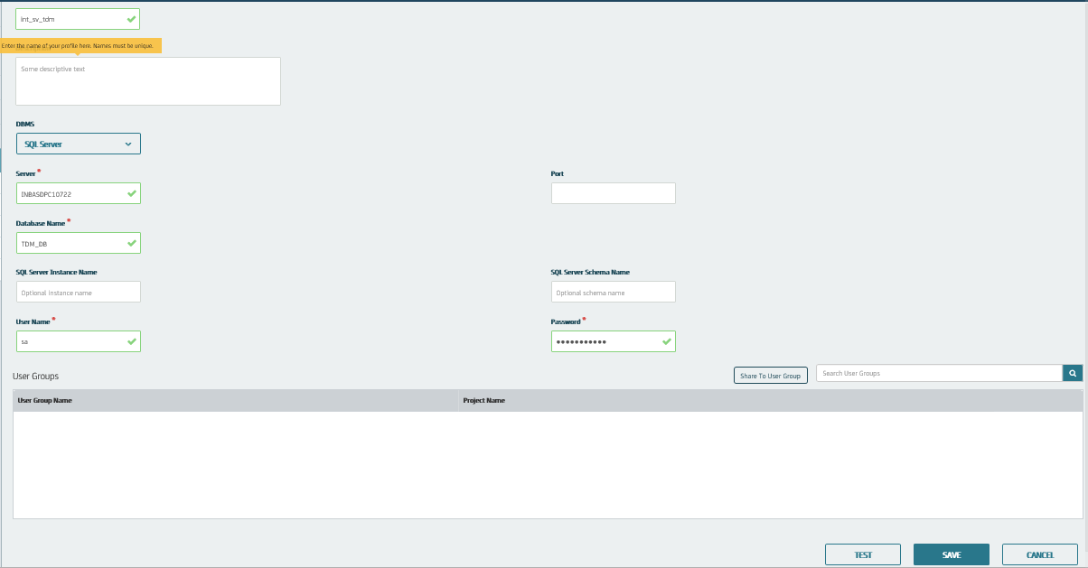

### **Register a File Object (WSDL)**

1. Select the appropriate project and its version from the **Project** list.
2. Click **Modeling** and then click **Objects**.
3. Click **Register New Object(s)**.
4. Select WSDL from the **Object Type**. Enter the object name in the **Name** field
5. Drag and drop the WSDL file. Click **Save** to register the WSDL file object.

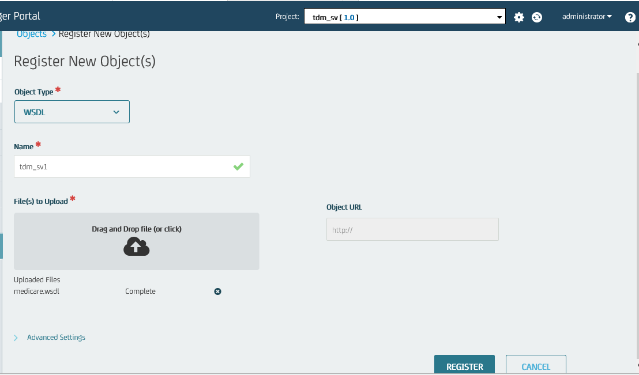

### **Create and Register Derived Objects**

When you create and register derived objects, schema is added to the relational database based on the registered WSDL file.

1. Click **Objects**. Select the object created.
2. Click the WSDL operation **GetSupplierByZipCode** in the table that lists the available WSDL operations for the registered WSDL file.
3. Select the appropriate connection profile.
4. Click the **Create and Register** button.

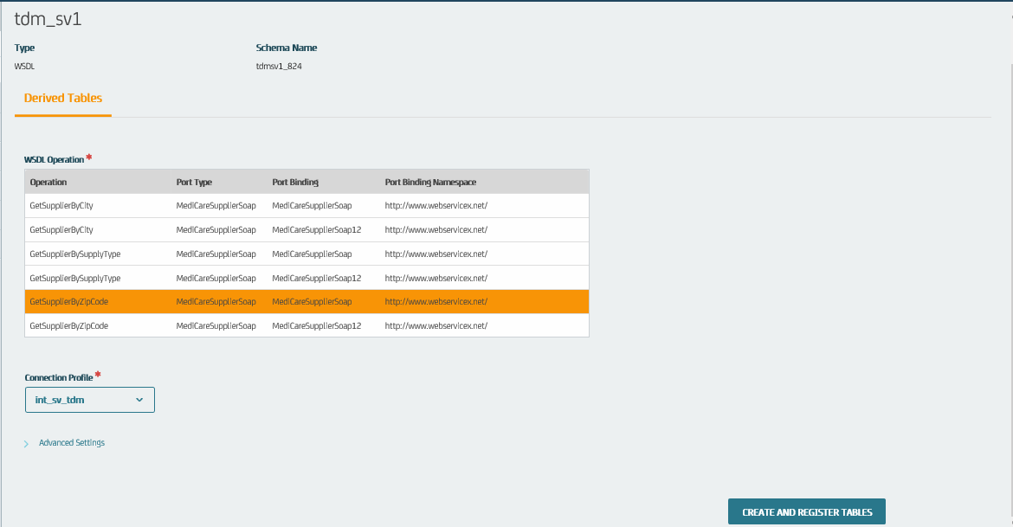

### **Create a Data Generator**

Create a data generator for your project.

1. Click **Generators >>** **New Generator** button.
2. Enter information in the following fields for this example:

* **Name:** Specify the data generator name.
* **Description:** Specify the data generator description.

1. **Click** **Save**.

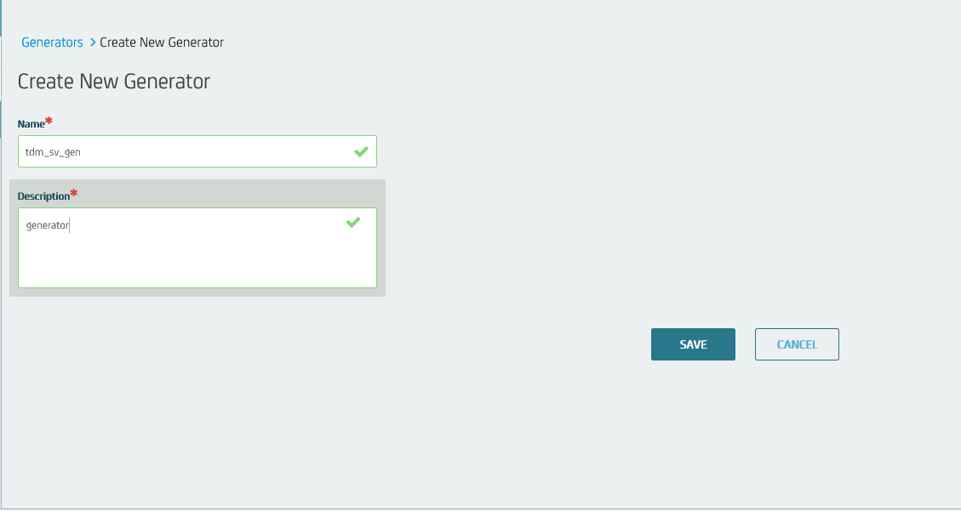

### **Import the Sample RR Pairs into Derived Objects**

Import the sample data (XML RR pairs) into the data generator and into the target database.

1. Click **Objects**. Select the object created.
2. Click the Import Data icon.

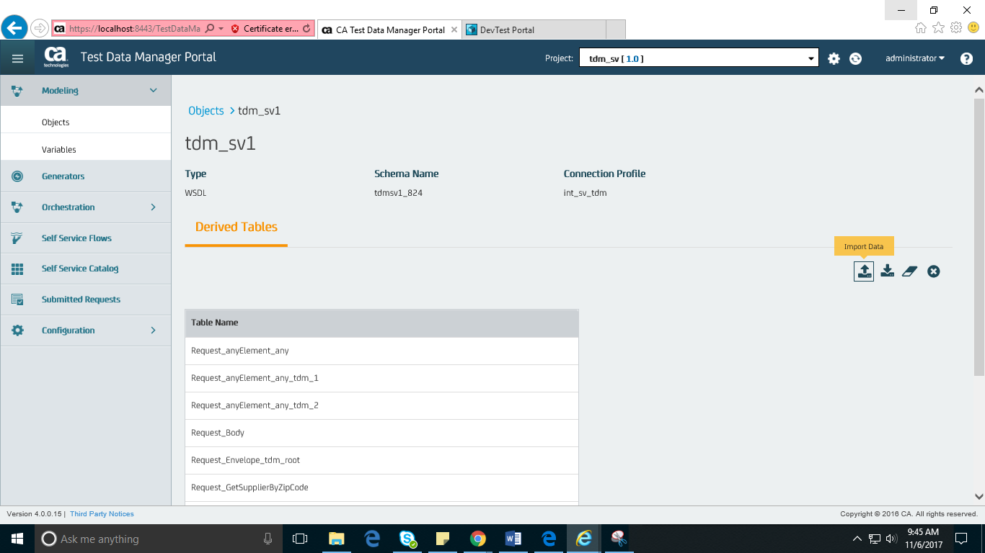

1. Enter information in the following fields:
   * **R/R Pair Link ID**: Specify the RR pair link ID.
   * **Advanced Settings:** Specify the connection profile and the schema name
   * **Request-File to Upload**: XML request file.
   * **Response-File to Upload**: XML response file
   * **Import to Generator**: Select this option.
   * **Data Generator Connection**: Specify the data generator.
2. Click the **Import** button.

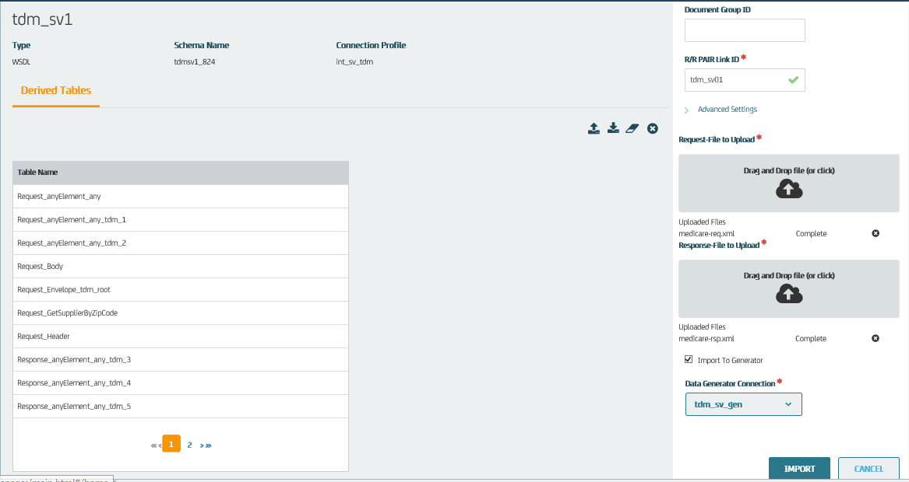

### **Verify Records in the Database After Import**

Access the Microsoft SQL Server database to verify that the sample data is added to the derived objects in the database. The derived object includes only one record, with the ZIP code as **60532.**

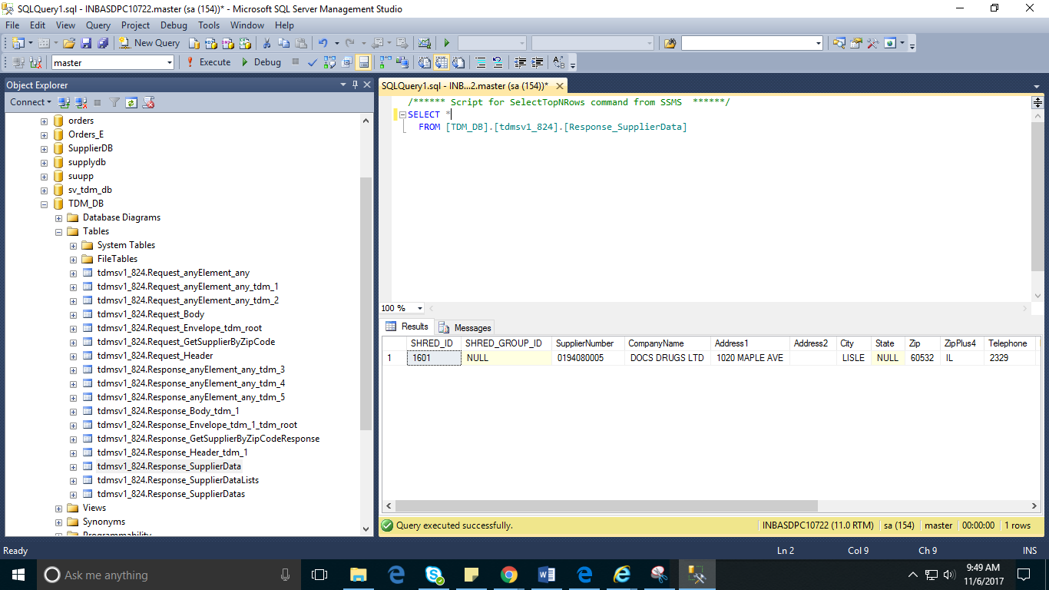

### **Add Data Generation Rules**

These rules help you add more data to your derived objects during the data publishing

1. Click **Generators**. Select data generator that is created.
2. Click the **Select Tables** button to open the **Registered Tables** dialog.
3. Click the **Relational Edit** button.
4. Select the **Make All Children References** and **Make All Parents default** options, and click **OK**.
5. Review the information in the **Relational Editor Results** dialog, and click **OK**.

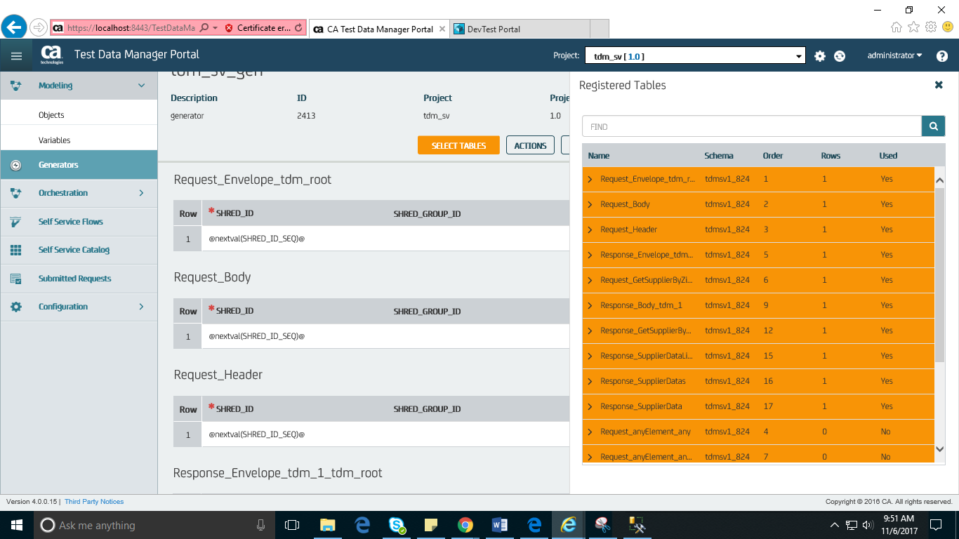

1. Add data generation rules for **Request_GetSupplierByZipCode**:

Zip: @randlov (0,@seedlist(US Zip-Codes)@)@

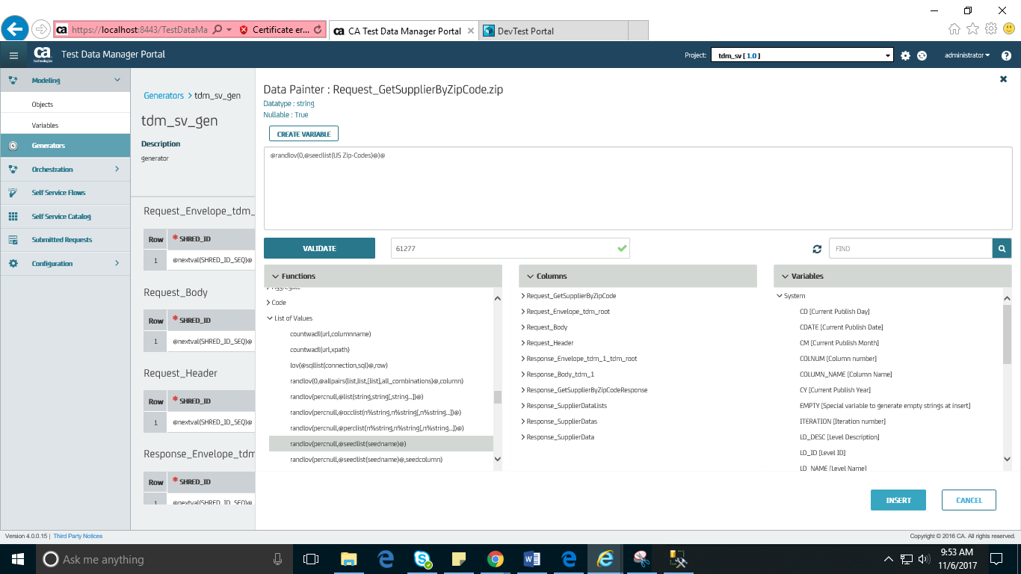

1. Add data generation rules to the appropriate cells of all the required derived objects.   
   Data generation rules added to the **Response_SupplierData** derived object are as follows:
   * SHRED_ID: @nextval(SHRED_ID_SEQ)@
   * SupplierNumber: @randlov(0, @seedlist(Car Parts)@)@
   * CompanyName: @randlov(0, @seedlist(Companies)@)@ LTD
   * Address1: @randlov(0,@seedlist(US Address Line 1)@,1)@
   * City: @randlov(0,@seedlist(US City State Zip County)@,1)@
   * Zip: ^Request_GetSupplierByZipCode.zip (1) ^
   * ZipPlus4: @randlov(0,@seedlist(US City State Zip County)@,2)@
   * Telephone: @randrange(2300,9800)@
   * Description: (@randrange(110,999)@)@randrange(110,999)@-@randrange(1110,1999)@
   * Response_SupplierDatas_SHRED_ID: ^Response_SupplierDatas.SHRED_ID(1)^

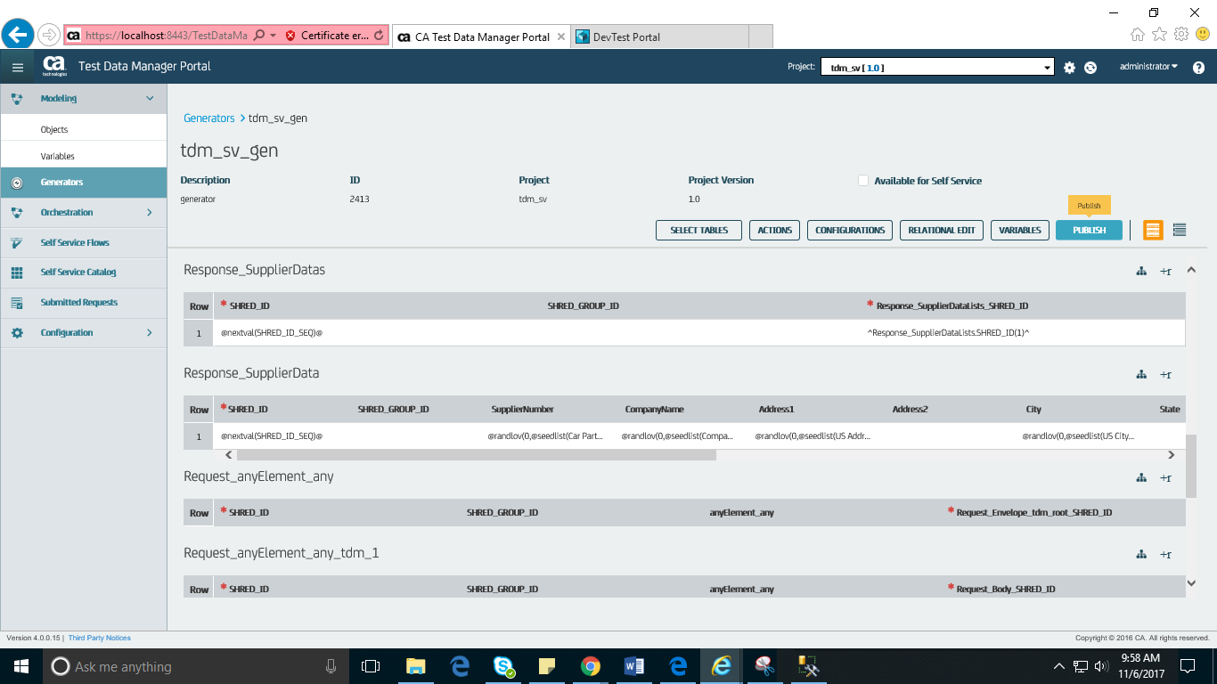

### **Publish More Data into Derived Objects**

1. Click the data generator created.
2. Click the **Select Tables** button to open the **Registered Tables** dialog.
3. Click the rows corresponding to the used derived objects that you want to use for the data publishing.
4. Review the data generation rules (added to the derived objects in the preceding procedure).
5. Click the **Publish** button.
6. Enter information in the following fields for this example:
   1. **Table Count:** Specify the table count value.
   2. **Publish to: Sp**ecify the connection profile.
   3. **Schema:** Specify the target schema name
   4. **Repeat:** Specify the value to provide the number of rows to add to the derived objects.
   5. **Email:** Specify the email ID where you want to send the publishing notifications.
   6. Schedule Publish: Select Now.
   7. Include in Publish: Select the check box that is available before the table name to include the table in the publish.
7. Click the **Publish** button.

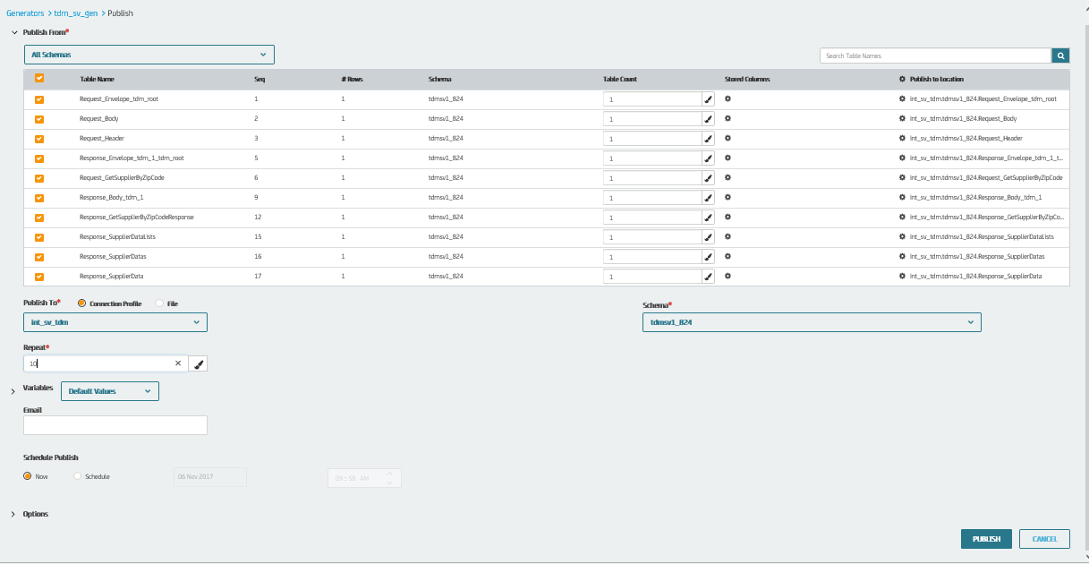

### **Verify Extra Records in the Database After Publishing**

Access the Microsoft SQL Server database to verify that extra rows are added to the derived objects in the target database. The same derived object now includes more records as a result of the publish process.

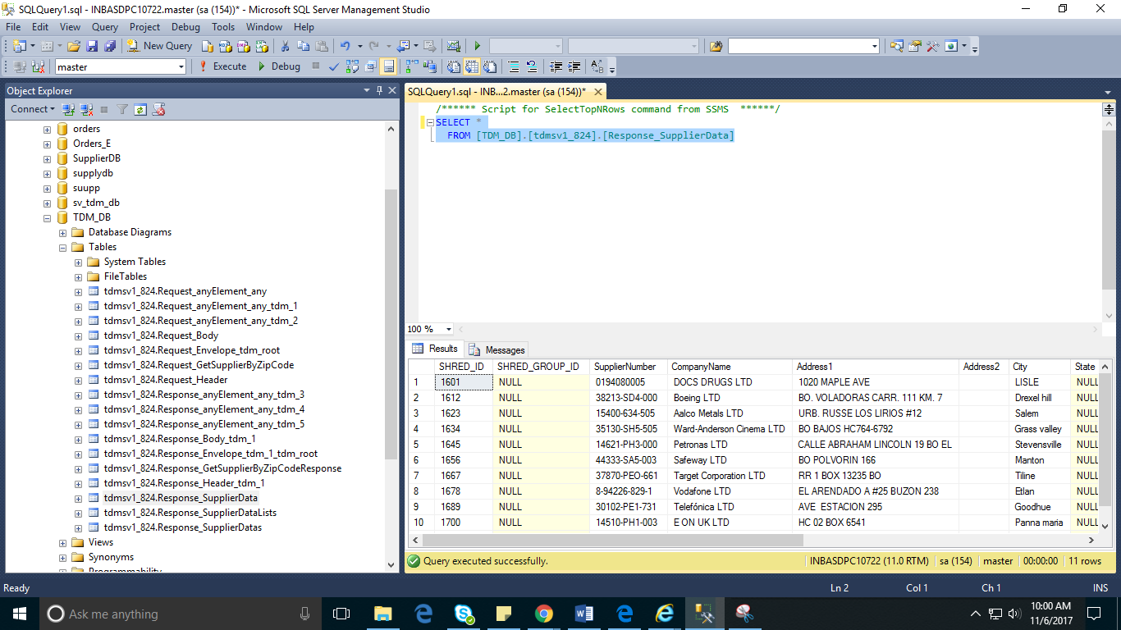

### **Create a Virtual Service in CA Service Virtualization**

Create a virtual service with the initial sample RR pair data that is used while importing RR pairs into derived objects and deploy them.

### **Configure the Virtual Service Connection in the CA TDM Portal**

To communicate with the required CA Service Virtualization environment, configure the CA TDM Portal with the appropriate virtual service-related information.

1. Click **Configuration** in the left pane.
2. Click the **DevTest Portal**option.
3. Enter information in the following fields for this example:
   * **Protocol:** Specify the protocol value to connect to the virtual service.
   * **Host Name:** Specify the name of the host where VSE is available.
   * **Port:** Specify the registry web service port number where the virtual service is running as 1505.
   * **Username:** Specify the name of the user having access to the VSE.
   * **Password:** Specify the password for the user.
4. Save the configuration details.

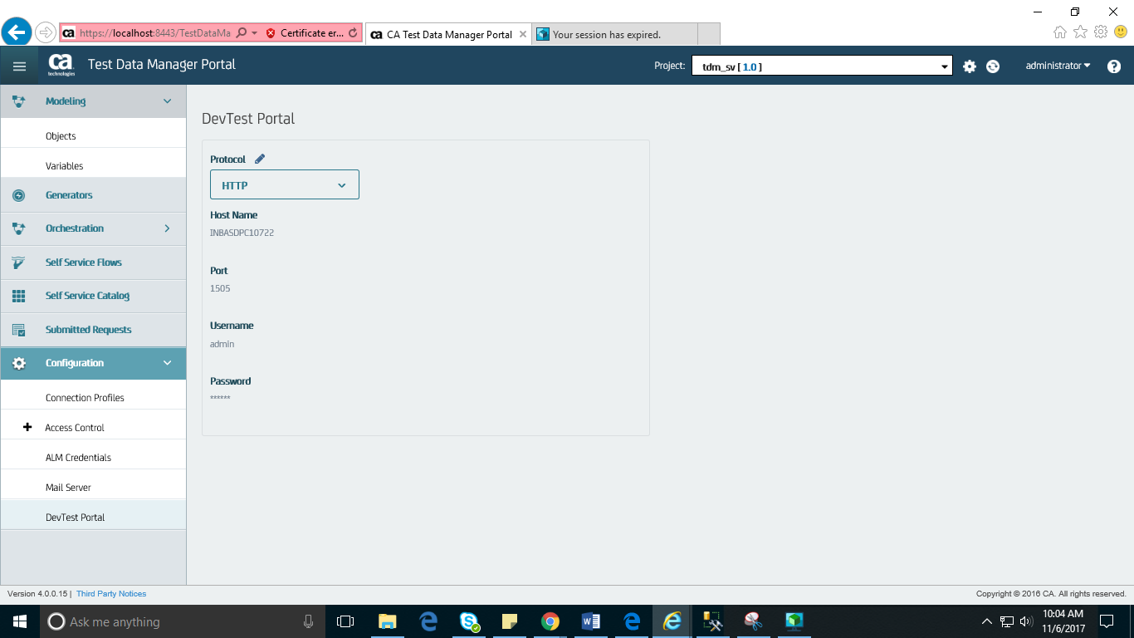

### **Export the Generated Data (RR Pairs) into the Virtual Service**

After you configure the CA TDM Portal to connect to the virtual service, you can export the generated data into the configured virtual service. The data is exported into the virtual service in the form of XML RR pairs.

1. In TDM Portal, click **Objects**.
2. Select the object to be used for the data export operation.
3. Click the Export Data icon (down arrow).
4. Enter information in the following fields for this example:
   * **Connection Profile:** Specify the connection profile name.
   * **Schema Name:** Specify the schema name.
   * **Update Virtual Service:** Select this option.
     + **Virtual Service Environment:** Specify the name of the VSE.
     + **Virtual Service:** Specify the name of the virtual service created in Workstation.
5. Click the **Export** button.

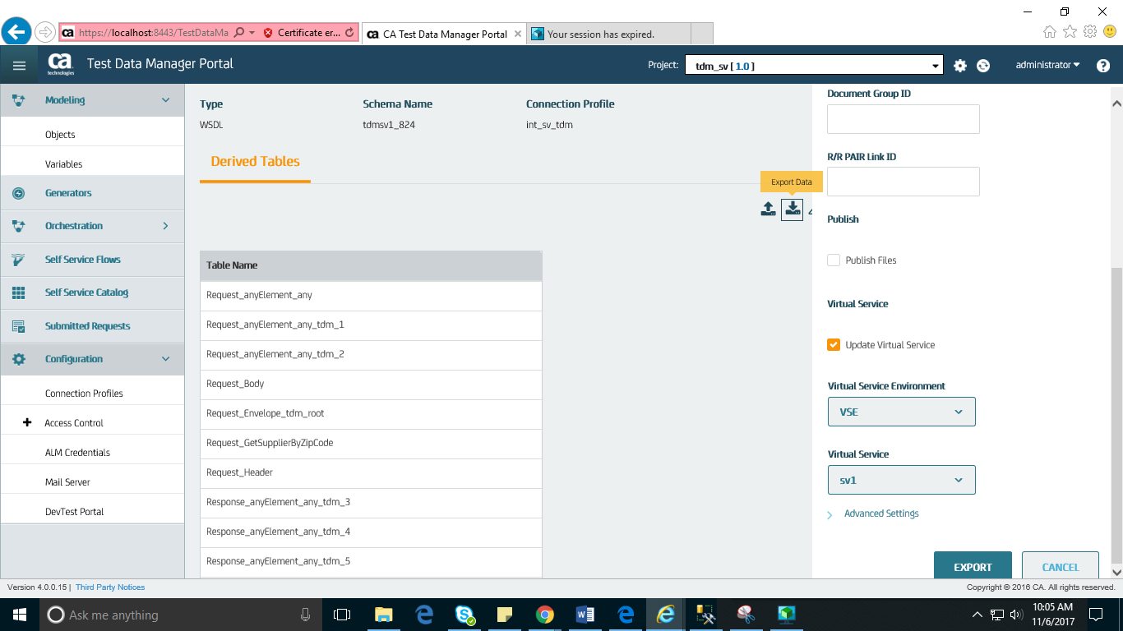

### **Verify the RR Pairs Added to the Virtual Service**

We can verify all the data available in the database is pushed into the virtual service in the form of XML RR pairs.

1. **In DevTest Workstation, Create New Test Case**.
2. Select **Add Step, Web/Web Services, Web Service Execution (XML)**.
3. Specify the location of the WSDL file (used for deriving objects) and the virtual service endpoint.
4. Paste the request body and provide the ZIP code (60532).
5. Click the arrow icon to execute the request.

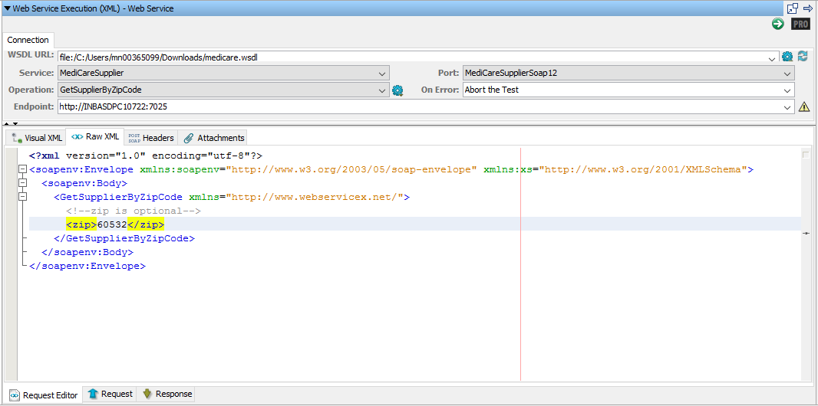

The appropriate response body is returned.

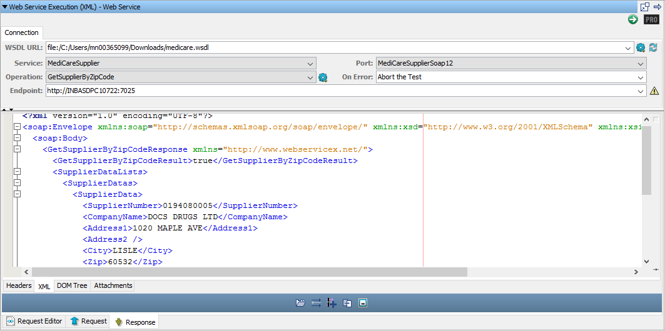

Provide the ZIP code **33407** which was added to the derived objects as a result of the data generation process. This ZIP code was not originally present in the derived objects

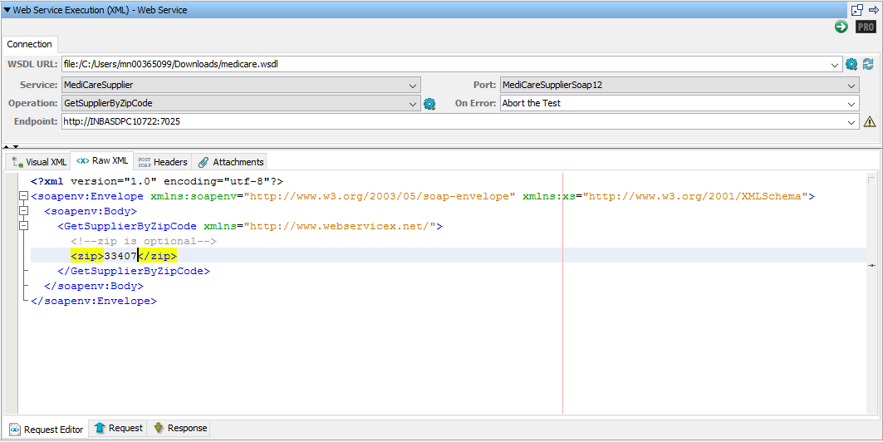

The appropriate response body is returned

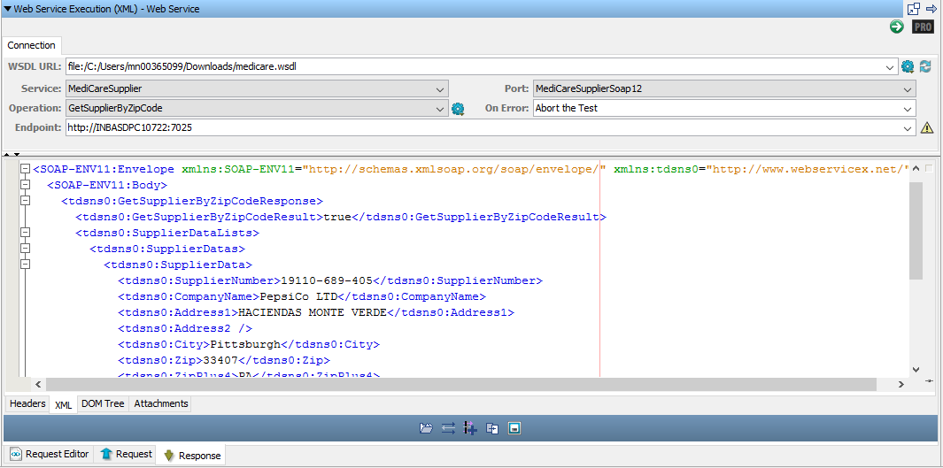

Same thing can be verified in SOAP UI as well.

Zip code: 60532

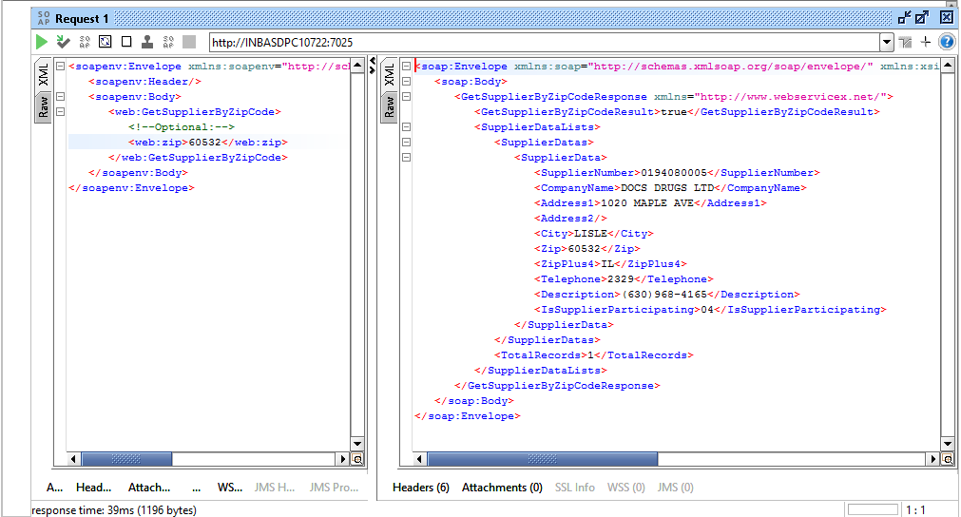

Zip code: 33407

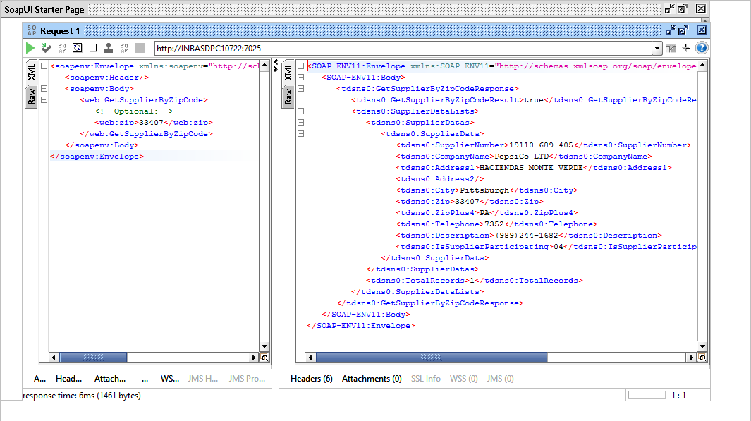

**New RR pairs that were exported, be available in the DevTest VSI**

1. Download the MAR file to get the generated data. Extract the MAR file.
2. Now open Workstation UI, and open the “Project” MAR file you just extracted.
3. Then select the VSI. You will see the TDM generated data in the response.

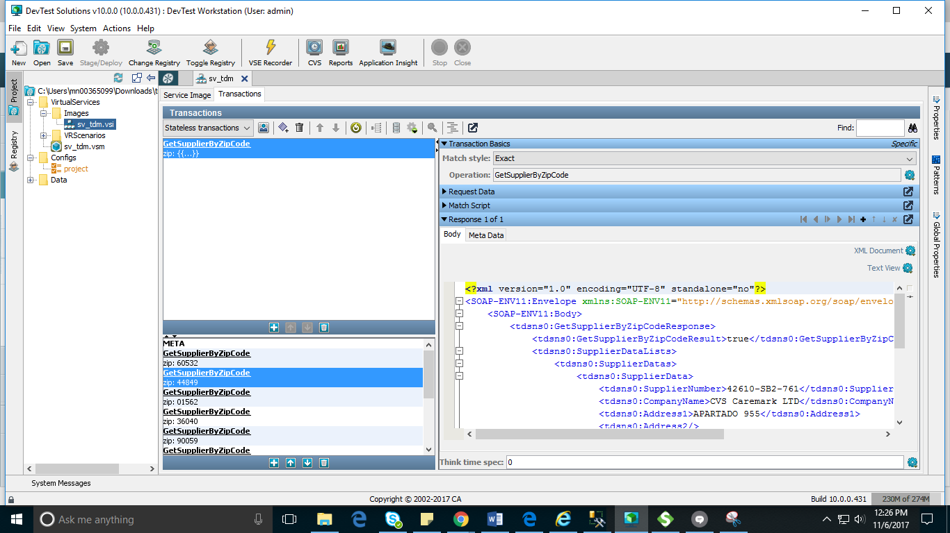

Below are the WSDL and RR pairs:

  